GEN 308 Shwe Pyae Eain 240702404706
LAB 2408-1 Item list (Add, Delete, Print selected, and Print all)

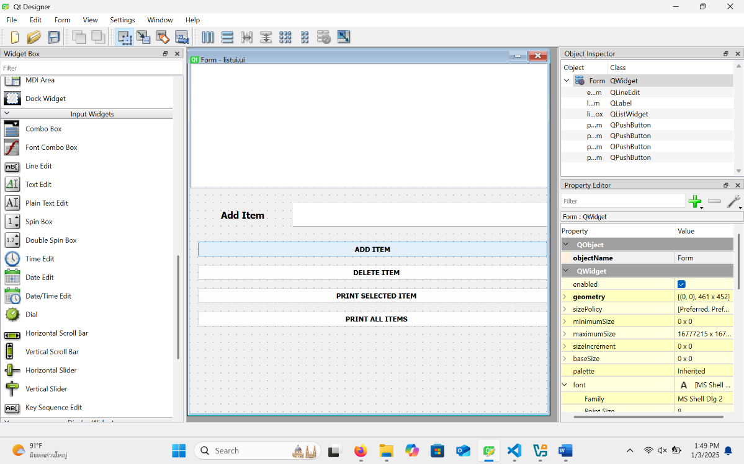
Figure 1 My UI design

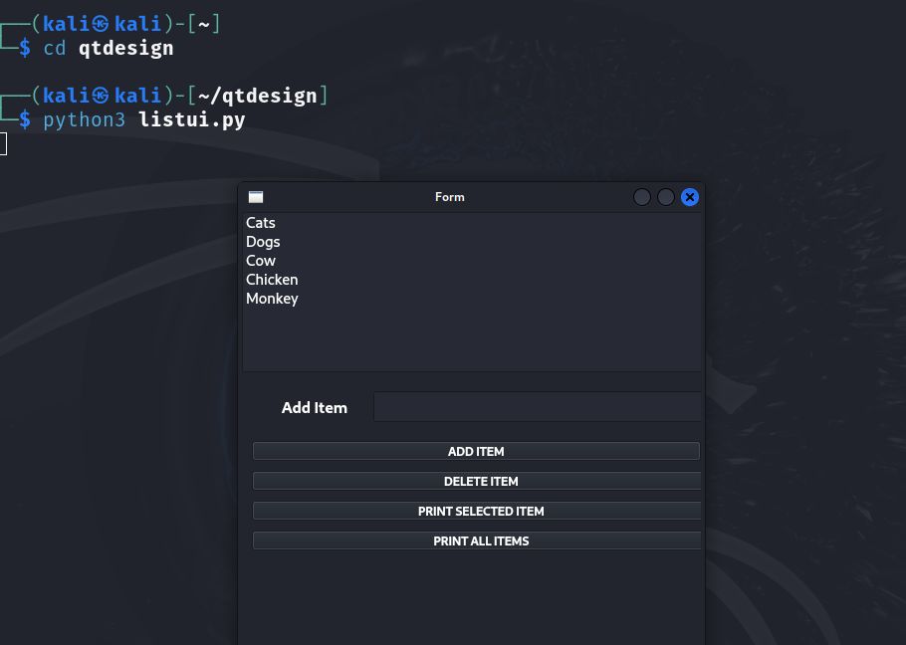
Figure 2 Added items into list box

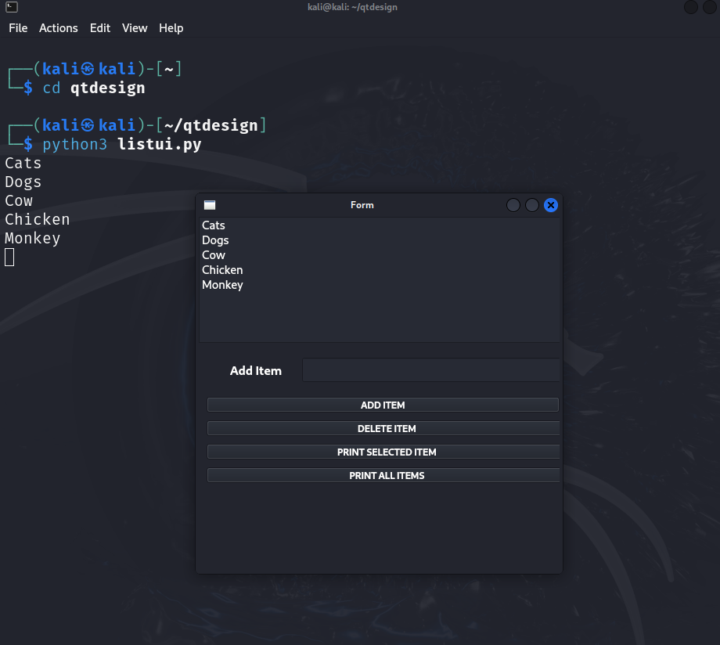
Figure 3 Clicked on “Print all items” to print all items from the list box

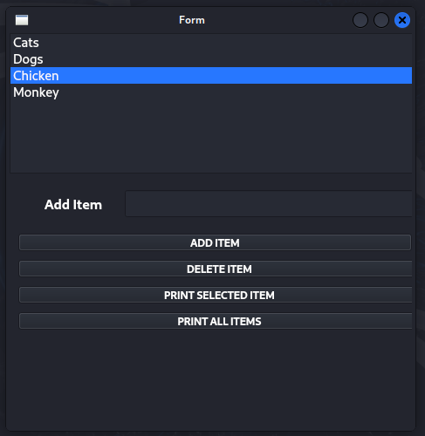
Figure 4 Deleted the selected item ( Cow ) from the list box

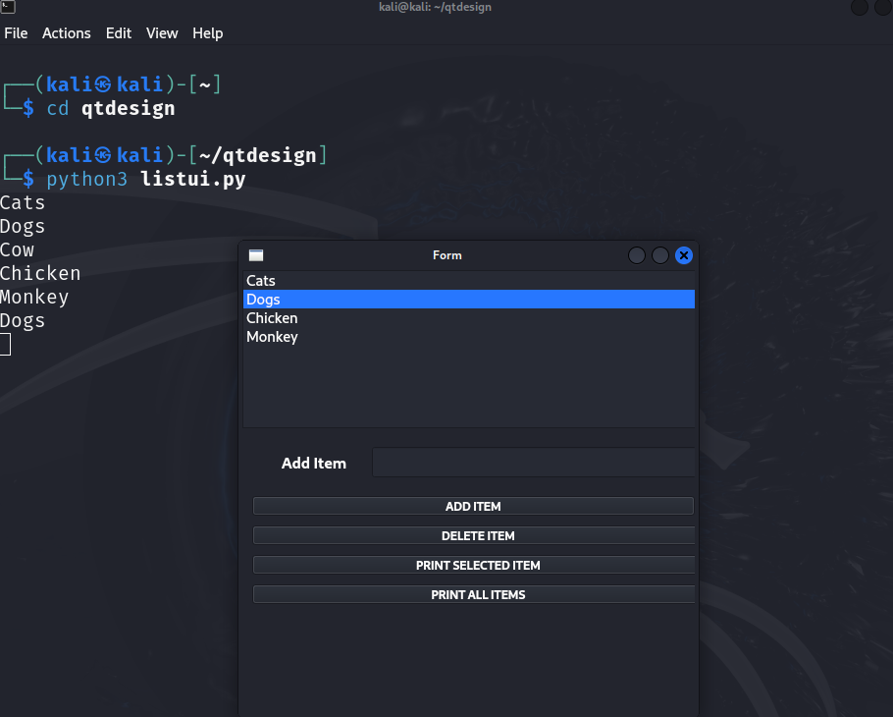

Figure 5 Printed the selected item ( Dogs ) from the list box

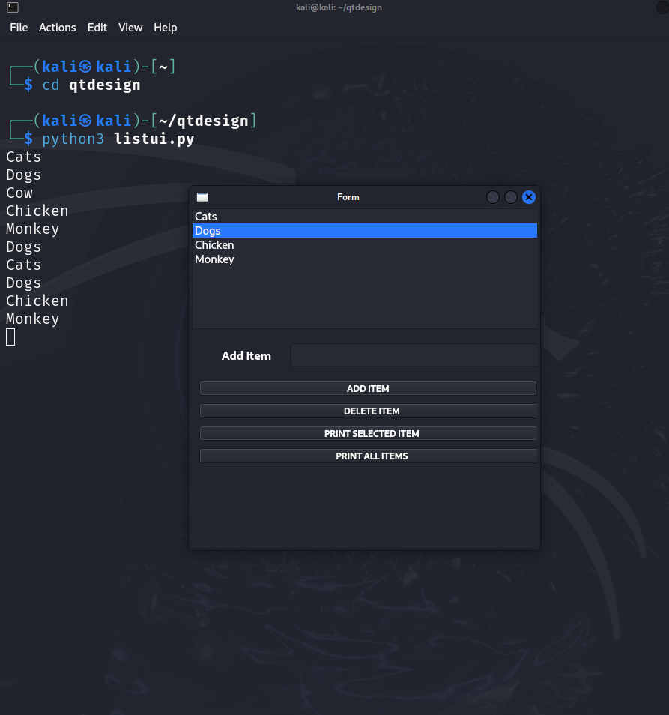
Figure 6 Printed All Items ( latest items in the list box)

